AP Calc AB Name: _______________

______________ _____________

WS Assessment

Target 22:

Area between curves

**I can:**

* Calculate the areas in the plane using the definite integral

Unit 8: Applications of Integration

HW Target 22 Unit 8 Progress Check MCQ

Find the area of the region enclosed by parabola y = 2 – x2 and the line y = x. Sketch

Find the area of the region enclosed by the graph of y = 2 cosx and y = x2 -1.Sketch.

Find the area of the region R in the first quadrant that is bounded above by $y=\sqrt{x}$ and below by the x-xis and the line y = x – 2 . Sketch

Redo problem using only one integral (i.e. Integrating with respect to y)

Find the area of the region enclosed by the graphs of y = x3 and x = y2 – 2. Sketch. Both

Find the area of circle, radius r. Sketch

Find the area of ellipse radius a, b. Sketch

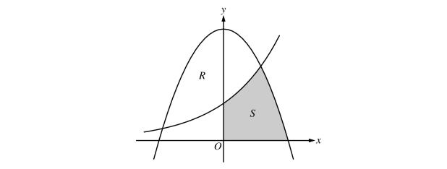Let *R* and *S* in the figure be defined as follows:*R* is the region in the first  
and second quadrants bounded by the graphs of *y* = 3 - *x2* and *y* = 2*x*.   
*S* is the shaded region in the first quadrant bounded by the two graphs,  
the x-axis, and the y-axis. Find the area of *S.*

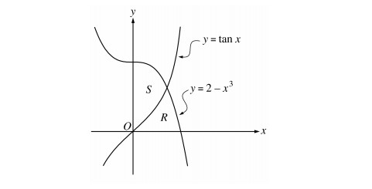

Let *R* and *S* be the regions in the first quadrant shown in the figure.

The region *R* is bounded by the *x*-axis and the graphs of *y* = 2 - *x*3 and

*y* = tan *x*. The region *S* is bounded by the *y*-axis and the graphs

of *y* = 2 - *x*3 and *y* tan *x*. Find the area of *R*.

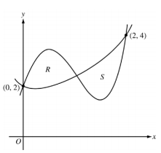

Let *f* and *g* be the functions defined by $y=1+x+e^{x^{2}-2x}$  and

*g*(*x*) = *x*4 - 6.5*x*2 + 6*x* +2. Let *R* and *S* be the two regions enclosed

by the graphs of *f* and *g* shown in the figure.

Find the sum of the areas of regions *R* and *S*.

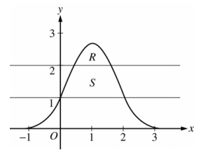

let *S* be the region bounded by the graph of $y=e^{2x-x^{2}}$

and the horizontal lines *y* =1 and *y* =2, as shown

Find the area of *S*

**Assessment**

Consider the curve *y*2 = 4 + *x* and chord *AB* joining the points *A*(−4,0) and *B*(0,2) on the curve.

Find the area of the region *R* enclosed by the curve and the chord *AB*.

Let *R* be the region in the first quadrant bounded by the *x*-axis and the graphs

of *y*= ln *x* and *y = 5 - x*

The vertical line x *= k* divides *R* into two regions of equal area. Find *k* and the area

The horizontal line *y = m*  divides *R* into two regions of equal area. Find m and the area

Let S be the region in the first quadrant bounded by the line x = 53y and the curve x = 1 + y2. Find the area of S (both ways)